MODULE: 3 (HTML 5)

• What are the new tags added in HTML5?

➢ New tags of HTML 5:-

➢  Article,

➢  aside,

➢  audio,

➢  canvas,

➢  command,

➢  datalist,

➢  details,

➢  embed,

➢  figcaption,

➢  figure,

➢  footer,

➢  header,

➢  hgroup,

➢  keygen,

➢  mark,

➢  meter,

➢  nav,

➢  output,

➢  progress,

➢  rp, ruby,

➢  section,

➢  source,

➢  summary,

➢  time,

➢  video

• How to embed audio and video in a webpage?

➢ To embed audio in HTML, we use the <audio> tag. Before HTML5, audio cannot be added to web pages in the Internet Explorer era.

The <vid eo> element allows us to embed video files into an HTML, very similar to the way images are embedded.

• Semantic element in HTML5?

➢ Semantic HTML elements are those that clearly describe their meaning in a human- and machine-readable way. Elements such as <header> , <footer> and <article> are all considered semantic because they accurately describe the purpose of the element and the type of content that is inside them.

MODULE: 3 (HTML 5)

• What are the new tags added in HTML5?

* New tags of HTML 5:-
*  Article,
*  aside,
*  audio,
*  canvas,
*  command,
*  datalist,
*  details,
*  embed,
*  figcaption,
*  figure,
*  footer,
*  header,
*  hgroup,
*  keygen,
*  mark,
*  meter,
*  nav,
*  output,
*  progress,
*  rp, ruby,
*  section,
*  source,
*  summary,
*  time,
*  video

• How to embed audio and video in a webpage?

* To embed audio in HTML, we use the <audio> tag. Before HTML5, audio cannot be added to web pages in the Internet Explorer era.

The <vid eo> element allows us to embed video files into an HTML, very similar to the way images are embedded.

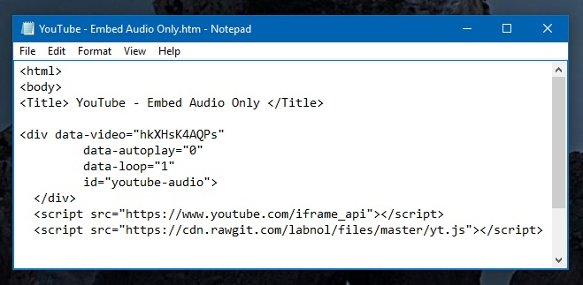

• Semantic element in HTML5?

* Semantic HTML elements are those that clearly describe their meaning in a human- and machine-readable way. Elements such as <header> , <footer> and <article> are all considered semantic because they accurately describe the purpose of the element and the type of content that is inside them.

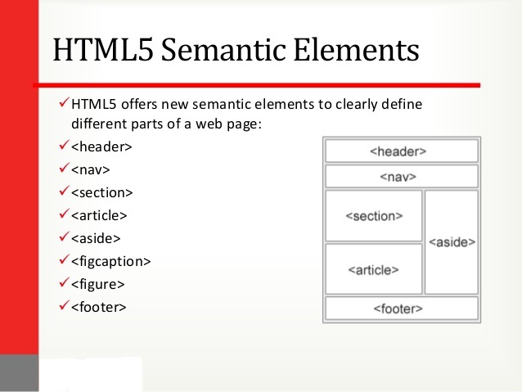

• Canvas and SVG tags

* SVG is a language for describing 2D graphics in XML. Canvas draws 2D graphics, on the fly (with a JavaScript). SVG is XML based, which means that every element is available within the SVG DOM. You can attach JavaScript event handlers for an element.

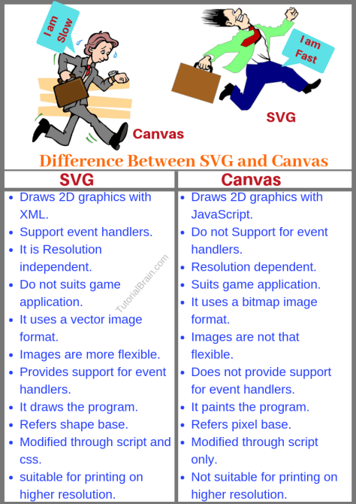

• Canvas and SVG tags

➢ SVG is a language for describing 2D graphics in XML. Canvas draws 2D graphics, on the fly (with a JavaScript). SVG is XML based, which means that every element is available within the SVG DOM. You can attach JavaScript event handlers for an element.